Section 5 – Extra Features

5.1 Design

This section will contain the systems needed to save, load, import and export images. This will be able to export the image created by the previous section:

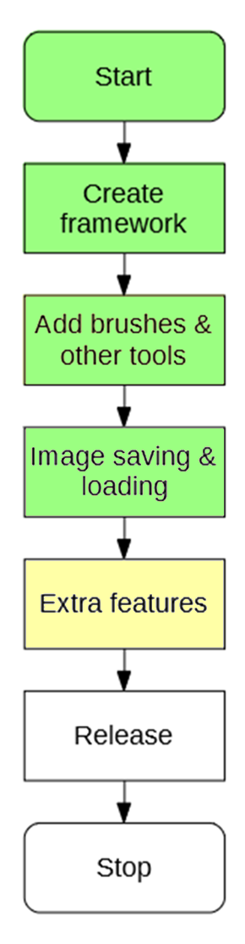

# 5.1.1 Success Criteria Fulfilment Plan

In this section the following success criteria are planned to be completed:

Not completed

To be done this section

Completed

|  |  |  |
| --- | --- | --- |
| **Feature** | **Proof** | **Code** |
| Section A - Brushes | | |
| Variable brush width | Screenshot of strokes of the same brush showing different widths | A1 |
| Hard brushes | Screenshot showing the hard edge of the brush (colour to no colour) | A2 |
| Shape creation tools | Screenshot showing the shape toolbar and a small selection of drawn shapes | A3 |
| Fill (bucket) tool | Screenshot showing a before and after of filling a large area | A4 |
| Single pixel pencil | Screenshot showing a stroke of the single pixel brush | A5 |
| Rubber | Screenshot showing a densely packed picture being rubbed out | A6 |
| Section B – Other editing tools | | |
| Image viewer | Screenshot of a currently being viewed image | B1 |
| Bitmap image editor | Screenshot of a zoom in on the image showing the pixels | B2 |
| RGB colour picker | Screenshot showing a system for entering an RGB colour | B3 |
| RGB direct input | Screenshot showing the user entering “FF0000” (or equivalent) and the programming outputting red | B4 |
| Layer system | Screenshot of layer navigator | B5 |
| Rectangle selection tool | Screenshot showing a rectangle selection on the image | B6 |
| Magic selection tool | Screenshot showing a complex selection around non-linear shape | B7 |
| Transparent pixels | Screenshot showing a layer with blank pixels (one layer on top of another). Partial transparency is not required | B8 |
| Zoom in (no zoom out) | Screenshot of an image at smallest zoom, followed by a screenshot at max zoom showing a portion of an image much smaller | B9 |
| Text | Screenshot of the text “Hello World” on the image | B10 |
| Eyedropper tool | Screenshot of an imported image, with the colour stroke of a colour taken from that image beneath it | B11 |
| *Image effects* | *Screenshot of an image before and after an effect is applied* | B12 |
| *Rotating Images* | *Screenshot of an image in 4 different rotations, normal, 90°, 180° and 270°* | B13 |
| *Clipping masks* | *Screenshot of an image being clipped onto a complex selection* | B14 |
| Section C – File System | | |
| Creating a new image | Screenshot of a blank 300x300 square image | C1 |
| Importing images | Screenshot of the file browser showing an image preview, and screenshot showing the image in the program | C2 |
| Exporting images | Screenshot showing a custom image in the program, followed by an image showing the file browser showing the image in a folder | C3 |
| Supporting PNG and JPEG | Screenshot showing the file browser which accepts both PNG and JPEG images | C4 |
| Saving and loading from a proprietary format | Screenshot showing the user saving an image, screenshot of the image in the file browser, and the program after the image is loaded | C5 |
| Section D – Usability | | |
| Program should be stable and not crash. | A complete testing table, showing no failed tests, followed 75% yes response to asking stakeholders “Did you encounter any errors while using the program?” | D1 |
| Program should be easy to use | 75% yes response to asking stakeholders “Did you find the program easy to use?” | D2 |
| Features should be easily accessible | From the default state of the program, any feature will need to be activated by no less than 4 clicks | D3 |

# 5.1.2 Decomposition

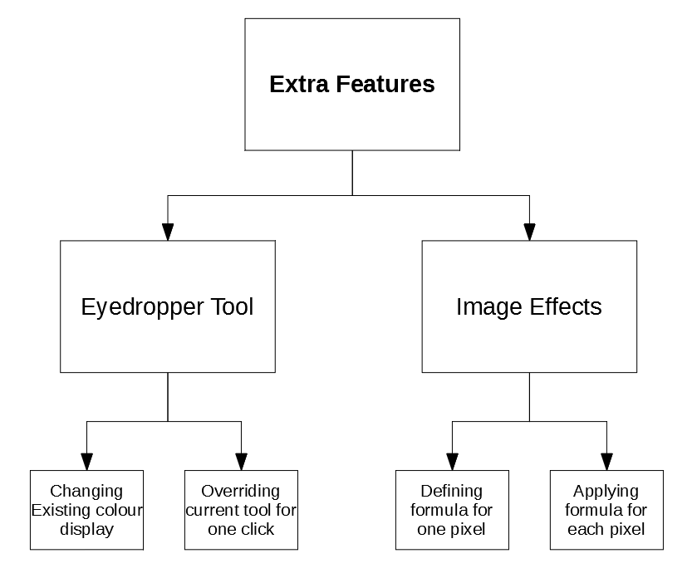

# 5.1.3 Class Design

## 5.1.3.1 EyedropperTool

The EyeDropperTool will be a special case, as it is not a normally accessible tool on the sidebar.

### Class Diagram

<class>

EyedropperTool

name*

description*

properties*

editingProperty

returnToTool

HandleMouseDown*

HandleMouseUp*

HandleMouseClick*

HandleMouseMove*

GetProperty*

SetColour

### Properties

|  |  |  |
| --- | --- | --- |
| **Property** | **Datatype** | **Justification** |
| name | String | Inherited from ITool |
| description | String | Inherited from ITool |
| properties | List of ToolProperties | Inherited from ITool |
| editingProperty | ColorProperty | The property that the eyedropper tool has been set to change |
| ReturnToTool | ITool | The tool that was selected before the eyedropper was |

### Methods

|  |  |  |  |
| --- | --- | --- | --- |
| **Method** | **Params** | **Return type** | **Justification** |
| HandleMouseDown | FilePoint clickLocation, MouseButton button | None | Inherited from ITool |
| HandleMouseUp | FilePoint clickLocation, MouseButton button | None | Inherited from ITool |
| HandleMouseClick | FilePoint clickLocation, MouseButton button | None | Inherited from ITool |
| HandleMouseMove | FilePoint oldLocation, FilePoint newLocation | None | Inherited from ITool |
| GetProperty | String propertyName | ToolProperty | Inherited from ITool |
| SetColour | ColorProperty property | None | When complete, will set the respective colourproperty to the new colour. |

## 5.1.3.2 FXTool

This tool will be responsible for the image effects and will contain the effects of:

* Grayscale
* Black & White
* Invert

### Class Diagram

<class>

FXTool

name*

description*

properties*

pixelTransformation

HandleMouseDown*

HandleMouseUp*

HandleMouseClick*

HandleMouseMove*

GetProperty*

ChangeImage

### Properties

|  |  |  |
| --- | --- | --- |
| **Property** | **Datatype** | **Justification** |
| name | String | Inherited from ITool |
| description | String | Inherited from ITool |
| properties | List of ToolProperties | Inherited from ITool |
| pixelTransformation | PixelTransformation | A formula for how each pixel will be changed |

### Methods

|  |  |  |  |
| --- | --- | --- | --- |
| **Method** | **Params** | **Return type** | **Justification** |
| HandleMouseDown | FilePoint clickLocation, MouseButton button | None | Inherited from ITool |
| HandleMouseUp | FilePoint clickLocation, MouseButton button | None | Inherited from ITool |
| HandleMouseClick | FilePoint clickLocation, MouseButton button | None | Inherited from ITool |
| HandleMouseMove | FilePoint oldLocation, FilePoint newLocation | None | Inherited from ITool |
| GetProperty | String propertyName | ToolProperty | Inherited from ITool |
| ChangeImage | None | None | Applies the current pixelTransformation onto each pixel in the image |

## 5.1.3.3 PixelTransformation

This class will contain a **delegate method** for what transformation should be applied to each pixel. The delegate is included in a class to impose proper encapsulation and readability.

<class>

PixelTransformation

transform

### Properties

|  |  |  |
| --- | --- | --- |
| **Property** | **Datatype** | **Justification** |
| transform | Delegate:  params: (colour) returns: (color) | Contains the algorithm to apply to each pixel in the image |

### Static Properties

To access these transformations, the PixelTransformation class will include a few static methods that return each sort of transformation:

|  |  |  |
| --- | --- | --- |
| **Static Property** | **Datatype** | **Justification** |
| Grayscale | PixelProperty | Contains the algorithm to convert a colour into grayscale |
| BlackAndWhite | PixelProperty | Contains the algorithm to convert a colour to black & white |
| Invert | PixelProperty | Contains the alogirthm to invert a colour |

## 5.1.3.4 ComboProperty

The user will need a way to select what image transformation they want to apply. This needs a new sort of property – one where an option can be selected from a few choices.

### Class Diagram

<class>

NumericalProperty

name*

value

options

### Properties

|  |  |  |
| --- | --- | --- |
| **Property** | **Datatype** | **Justification** |
| name* | String | Inherited from IToolProperty |
| value | String | Stores the value of the property |
| options | Array of String | Stores the possible options to choose from. |

# 5.1.4 Algorithm Design

## Algorithm 5.1 Changing existing colour display

The current display for a colour looks like:

Colour

This should be changed to look like:



Colour

Where the eyedropper button initiates the tool.

## Algorithm 5.2 Overriding current tool for one click

When created, the ReturnToTool property of the EyeDropper tool can be set to the tool that was selected. Then, upon clicking:

HandleMouseClick(clickLocation) {  
 colour = image.GetColour(clickLocation)  
 editingProperty.value = colour  
 workspace.currentTool = returnToTool  
 workspace.displayTool()  
}

Redisplays the tool as the colour has changed

## Algorithm 5.1 & Algorithm 5.2 Unit Test

|  |  |  |  |
| --- | --- | --- | --- |
| Test | ID | Expected Result | Comment |
| Opening a tool with a color property | 1 | Color has option to use the eyedropper tool on it. | This makes sure that the eyedropper tool button is correctly visible. |
| Pressing the eyedropper button | 2 | Button indicates that it is activated and eyedropper is active | This makes sure that the user is aware the tool is active |
| Selecting a point on the image | 3 | Color is changed to the color at the point pressed and eyedropper deselects | This is to make sure that the cycle is completed fully |
| Selecting the eyedropper tool again | 4 | The same process can be done, same as first time eyedropper is pressed | This makes sure the eyedropper tool is reset correctly |
| Selecting a point not on the image | 5 | The tool is still active and no colour is changed | Tests that the program handles clicking at a point not on the image |
| Pressing the eyedropper button again whilst it is selected | 6 | The tool deactivates and normal execution resumes | Tests that the eyedropper can be deselected if user wants to |
| Selecting another tool with eyedropper active | 7 | Eyedropper deactivates and new tool is selected | Tests that the program handles deselecting eyedropper when a different tool is selected |
| Selecting a transparent pixel | 8 | White is returned instead | Tests that the eyedropper returns the correct displayed colour as white is displayed at completely transparent points |

## Algorithm 5.3 Defining formula for one pixel

In order to do this, formulas must be defined for the three planned transformations:

* Grayscale
* Black & White
* Invert

### Algorithm 5.3A Grayscale

This can be achieved by finding the average of the three colours:

Grayscale(colour) {   
 total = colour.R + colour.G + colour.B  
 average = total / 3  
 return new Color(average,average,average)  
}

R, G and B all use the same average value

### Algorithm 5.3B Black & White

This can be achieved by finding the average, and checking if it is above a certain threshold:

BlackAndWhite(colour) {  
 total = colour.R + colour.G + colour.B  
 average = total / 3  
 IF average < 127 THEN  
 return White  
 ELSE  
 return Black  
 END IF  
}

### Algorithm 5.3C Invert

This can be achieved by subtract each of R, G and B from 255 (the maximum)

Invert(colour) {  
 newR = 255 – colour.R  
 newG = 255 – colour.G  
 newB = 255 – colour.B  
 return new Colour(newR,newG,newB)  
}

## Algorithm 5.4 Applying formula for each pixel

To then apply the formula for each pixel, the image can be iterated through and the current transformation’s algorithm will execute on each pixel:

ChangeImage() {  
 FOR x = 0 TO width  
 FOR y = 0 TO height  
 oldColor = image.GetPixel(x,y)  
 newColor = currentTransformation.transform(oldColor)  
 image.SetPixel(x,y,newColor)  
 NEXT  
 NEXT  
}

## Algorithm 5.3 & Algorithm 5.4 Unit Test

|  |  |  |  |
| --- | --- | --- | --- |
| Test | ID | Expected Result | Comment |
| Apply grayscale transformation | 1 | The image becomes shades of grey | Tests that the grayscale transformation functions correctly |
| Apply black & white transformation | 2 | The image becomes black and white | Tests that black and white transformation functions correctly |
| Apply invert transformation | 3 | The colours of the image invert (e.g. green -> purple) | Tests that the invert transformation functions correctly |
| Apply invert transformation twice | 4 | The colours return to normal | Tests that the invert is reversible |

5.2 Development

# 19/12/2019 Adding Eyedropper

## Algorithm 5.1 & Algorithm 5.2 Unit Test

|  |  |  |  |  |
| --- | --- | --- | --- | --- |
| Test | ID | Expected Result | Actual Result | Comment |
| Opening a tool with a color property | 1 | Color has option to use the eyedropper tool on it. |  | This makes sure that the eyedropper tool button is correctly visible. |
| Pressing the eyedropper button | 2 | Button indicates that it is activated and eyedropper is active |  | This makes sure that the user is aware the tool is active |
| Selecting a point on the image | 3 | Color is changed to the color at the point pressed and eyedropper deselects |  | This is to make sure that the cycle is completed fully |
| Selecting the eyedropper tool again | 4 | The same process can be done, same as first time eyedropper is pressed |  | This makes sure the eyedropper tool is reset correctly |
| Selecting a point not on the image | 5 | The tool is still active and no colour is changed |  | Tests that the program handles clicking at a point not on the image |
| Pressing the eyedropper button again whilst it is selected | 6 | The tool deactivates and normal execution resumes |  | The eyedropper tool is selected again, causing a crash when trying to return to the previous tool |
| Selecting another tool with eyedropper active | 7 | Eyedropper deactivates and new tool is selected |  | Tests that the program handles deselecting eyedropper when a different tool is selected |
| Selecting a transparent pixel | 8 | White is returned instead |  | This case has not been handled, so returns a transparent colour |

## Fixing Error #6

The error is caused by the program not checking whether the eyedropper is currently selected. It can be fixed by adding this check:

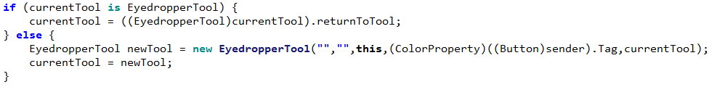

## Fixing Error #8

This can be fixed with a single line, replacing the colour with white if it is transparent



|  |  |  |  |  |
| --- | --- | --- | --- | --- |
| Test | ID | Expected Result | Actual Result | Comment |
| Pressing the eyedropper button again whilst it is selected | 6 | The tool deactivates and normal execution resumes |  | The eyedropper tool now deselects when pressed again |
| Selecting a transparent pixel | 8 | White is returned instead |  | The new line returns white |

# 20/12/2019 Adding FX

## Implementing Delegate System

The delegate system is implemented as a part of the PixelTransformation class. It is defined, then PixelTransformation is given it as a property:

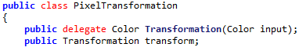

Then, when creating the static members, the transform member can be set to the necessary code:

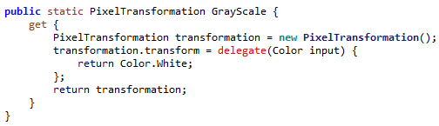

In this case, the colour is returned as white always. Thus when applying this transformation the code is very simple, the delegate is called and passed the colour it needs:

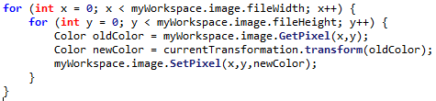

This closely follows the previously laid out design:

ChangeImage() {  
 FOR x = 0 TO width  
 FOR y = 0 TO height  
 oldColor = image.GetPixel(x,y)  
 newColor = currentTransformation.transform(oldColor)  
 image.SetPixel(x,y,newColor)  
 NEXT  
 NEXT  
}

## Implementing Grayscale

The grayscale can be implemented in accordance to the designed algorithm:

Grayscale(colour) {   
 total = colour.R + colour.G + colour.B  
 average = total / 3  
 return new Color(average,average,average)  
}

R, G and B all use the same average value

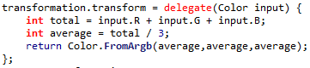

## Implementing Black & White

BlackAndWhite(colour) {  
 total = colour.R + colour.G + colour.B  
 average = total / 3  
 IF average < 127 THEN  
 return White  
 ELSE  
 return Black  
 END IF  
}

However, this algorithm can be improved as the total does not need to be divided by 3, the total can be compared to 127 * 3:

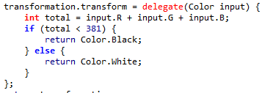

## Implementing Invert

Invert(colour) {  
 newR = 255 – colour.R  
 newG = 255 – colour.G  
 newB = 255 – colour.B  
 return new Colour(newR,newG,newB)  
}

# 17/01/2020 Final Changes

## Transparency Saving error

While doing Beta Testing with clients, an error was discovered that was not found in Alpha Testing. When saving layers, the Red, Green and Blue values was saved, meaning that transparency was **not** saved. This should be resolved so that transparency is saved.

So the saving code has been changed to save the alpha (transparency) channel.

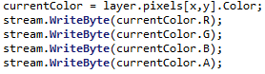

However this means that the file format has been changed during beta testing – however my clients would like their older SIMP files to remain compatible.

## Introducing File Versioning

Now that the file saving has been changed, the header has also been changed to denote that it is a different type of SIMP file. (SIM2 = SIMP2)

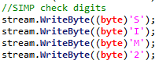

Then, when loading, the image, there is a switch case to decide what sort of file it is:







Then, in the SIM2 loading, the alpha channel is loaded.

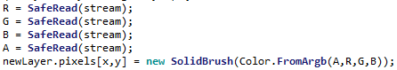

# Success Criteria Evaluation

|  |  |  |
| --- | --- | --- |
| **Feature** | **Proof** | **Code** |
| Section B – Other Editing Tools | | |
| Eyedropper tool | Screenshot of an imported image, with the colour stroke of a colour taken from that image beneath it | B11 |
| *Image effects* | *Screenshot of an image before and after an effect is applied* | B12 |
| Section D – Usability | | |
| Program should be stable and not crash. | A complete testing table, showing no failed tests, followed 75% yes response to asking stakeholders “Did you encounter any errors while using the program?” | D1 |
| Program should be easy to use | 75% yes response to asking stakeholders “Did you find the program easy to use?” | D2 |
| Features should be easily accessible | From the default state of the program, any feature will need to be activated by no less than 4 clicks | D3 |

|  |  |  |
| --- | --- | --- |
| **Feature** | **Proof** | **Code** |
| Section A - Brushes | | |
| Variable brush width | Screenshot of strokes of the same brush showing different widths | A1 |
| Hard brushes | Screenshot showing the hard edge of the brush (colour to no colour) | A2 |
| Shape creation tools | Screenshot showing the shape toolbar and a small selection of drawn shapes | A3 |
| Fill (bucket) tool | Screenshot showing a before and after of filling a large area | A4 |
| Single pixel pencil | Screenshot showing a stroke of the single pixel brush | A5 |
| Rubber | Screenshot showing a densely packed picture being rubbed out | A6 |
| Section B – Other editing tools | | |
| Image viewer | Screenshot of a currently being viewed image | B1 |
| Bitmap image editor | Screenshot of a zoom in on the image showing the pixels | B2 |
| RGB colour picker | Screenshot showing a system for entering an RGB colour | B3 |
| RGB direct input | Screenshot showing the user entering “FF0000” (or equivalent) and the programming outputting red | B4 |
| Layer system | Screenshot of layer navigator | B5 |
| Rectangle selection tool | Screenshot showing a rectangle selection on the image | B6 |
| Magic selection tool | Screenshot showing a complex selection around non-linear shape | B7 |
| Transparent pixels | Screenshot showing a layer with blank pixels (one layer on top of another). Partial transparency is not required | B8 |
| Zoom in (no zoom out) | Screenshot of an image at smallest zoom, followed by a screenshot at max zoom showing a portion of an image much smaller | B9 |
| Text | Screenshot of the text “Hello World” on the image | B10 |
| Eyedropper tool | Screenshot of an imported image, with the colour stroke of a colour taken from that image beneath it | B11 |
| *Image effects* | *Screenshot of an image before and after an effect is applied* | B12 |
| *Rotating Images* | *Screenshot of an image in 4 different rotations, normal, 90°, 180° and 270°* | B13 |
| *Clipping masks* | *Screenshot of an image being clipped onto a complex selection* | B14 |
| Section C – File System | | |
| Creating a new image | Screenshot of a blank 300x300 square image | C1 |
| Importing images | Screenshot of the file browser showing an image preview, and screenshot showing the image in the program | C2 |
| Exporting images | Screenshot showing a custom image in the program, followed by an image showing the file browser showing the image in a folder | C3 |
| Supporting PNG and JPEG | Screenshot showing the file browser which accepts both PNG and JPEG images | C4 |
| Saving and loading from a proprietary format | Screenshot showing the user saving an image, screenshot of the image in the file browser, and the program after the image is loaded | C5 |
| Section D – Usability | | |
| Program should be stable and not crash. | A complete testing table, showing no failed tests, followed 75% yes response to asking stakeholders “Did you encounter any errors while using the program?” | D1 |
| Program should be easy to use | 75% yes response to asking stakeholders “Did you find the program easy to use?” | D2 |
| Features should be easily accessible | From the default state of the program, any feature will need to be activated by no less than 4 clicks | D3 |